The prize stickers on the bottles like the following photo that will be helpful for you to show your olive oils with the prizes.

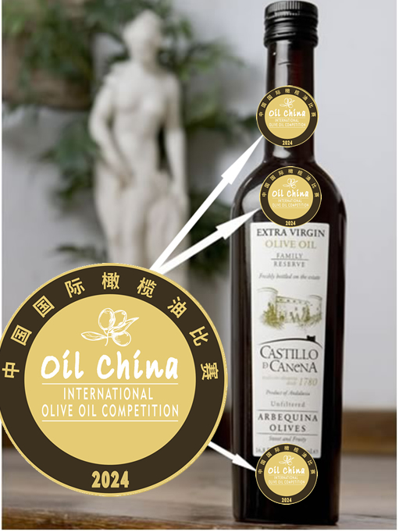 ‘

The Shape of finished prize stickers
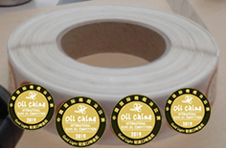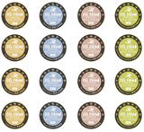
Left-handed or right-handed scroll sticker paper

19th Oil China Competition 2024
Prize Stickers Order Form

According to the rule of Oil China Competition 2024, the winners will have the privilege to order the quite quantities of prize stickers from the organizer, and the prize stickers may be pasted on the bottles of your olive oils that are awarded in 2024. The shape of finished prize stickers is scroll or paper. If you want to order the stickers for your awarded olive oils, please fill this form and then send to the organizer in time:

the 2024 Prize Stickers (we may provide the finished stickers for you)
No. | Item | Unit Price | I | M | L | O | Number | amount
1 | Gold Prize Stickers Set | € 60 or $ 65 per set
2 | Silver Prize Stickers Set | € 60 or $ 65 per set
3 | Bronze Award Stickers Set | € 60 or $ 65 per set
4 | Grand Mention Prize Stickers Set | € 60 or $ 65 per set
 | Total Cost
I=Intense; M=Medium; L= Light; O=Organic (tick off √)
Note:
- Each SET contains 1,000 individual prize stickers.
- The shape of finished prize stickers: ( ) left-handed scroll ( ) right-handed scroll ( ) paper
- The above cost does not contain the Freight Charge, so please tick off √ as follows:
( ) The stickers will be sent to your agent or representatives in China, the delivery is FREE
( ) If you have the account of the carriers like DHL,TNT or other carriers, please write down your account number: (□DHL □TNT □UPS □FEDEX □ other: )
( ) The stickers will be sent to you directly by the organizer, you should additionally pay the freight charge that is euro 80 (1-3 sets) or euro 110 (4-5 sets) or euro 160 (5-10 sets) or more than 200 (over 10 sets).

When we receive your order form, we shall send you the invoice and then you may make the payment by Wechat Pay, Paypal or Credit Card or bank transfer.

Company Name:
Address:
Name of Person In Charge: |  | DATE:
Tel: | E-mail: | DATE:
Please send the above form by email To: Regalland  Contact: Ms. Jenny Yang  E-mail: info@eoliveoil.com Tel:0086 10 64416542 |  | SIGNATURE:

